SURVEY REPORT GENERATOR
@CREATIVITY THINK (9483175986/7019689991)

ABSTRACT:
Survey Report Generator is a web-based application designed to facilitate the creation, distribution, and analysis of surveys across organizations. The platform allows users to participate in surveys, view personalized results, provide feedback, and track progress through an interactive dashboard. Administrators can create and manage surveys, moderate responses, and generate comprehensive analytics. Built with Django and Django Rest Framework for backend processing, and React with recharts and redux for frontend operations, the system ensures efficient survey management, real-time result visualization, and data-driven insights for HR, educational institutions, training programs, and clubs..

INTRODUCTION OF THE PROJECT:
Organizations often need structured tools to collect opinions, feedback, or performance data. Traditional survey methods such as paper forms or simple online forms lack robust analytics, participant tracking, and dashboard reporting. Survey Report Generator addresses these limitations by providing a centralized digital platform for creating, administering, and analyzing surveys. The system ensures transparency, accuracy, and actionable insights through real-time result tracking and interactive visualizations, enabling better decision-making and effective feedback management..

PROJECT OBJECTIVES:

• Enable administrators to create and manage surveys efficiently
• Allow participants to take surveys and provide feedback
• Track survey completion and participation status
• Provide dashboard analytics with charts and graphs
• Allow exporting of survey results and reports
• Moderate responses to maintain data integrity
• Support real-time feedback visualization
• Ensure secure storage of survey data and participant information

PROBLEM OF THE STATEMENT:
Organizations face challenges in conducting surveys efficiently and analyzing results accurately. Manual surveys or basic online forms often fail to provide instant analytics, participant tracking, or visualization tools. Administrators struggle to moderate responses and extract actionable insights. Survey Report Generator solves these issues by offering a comprehensive web platform for creating surveys, monitoring responses, visualizing results, and generating reports, streamlining the survey management process and improving decision-making..

MOTIVATION OF THE PROJECT:
• To replace traditional survey methods with a structured digital platform
• To provide real-time analytics for informed decision-making
• To improve participant engagement and response tracking
• To enable administrators to moderate and manage survey data
• To offer an intuitive interface for both users and administrators
• To generate actionable insights through dashboards and charts
• To facilitate feedback collection and reporting efficiently

BLOCK DAIGRAM OF PROJECT:

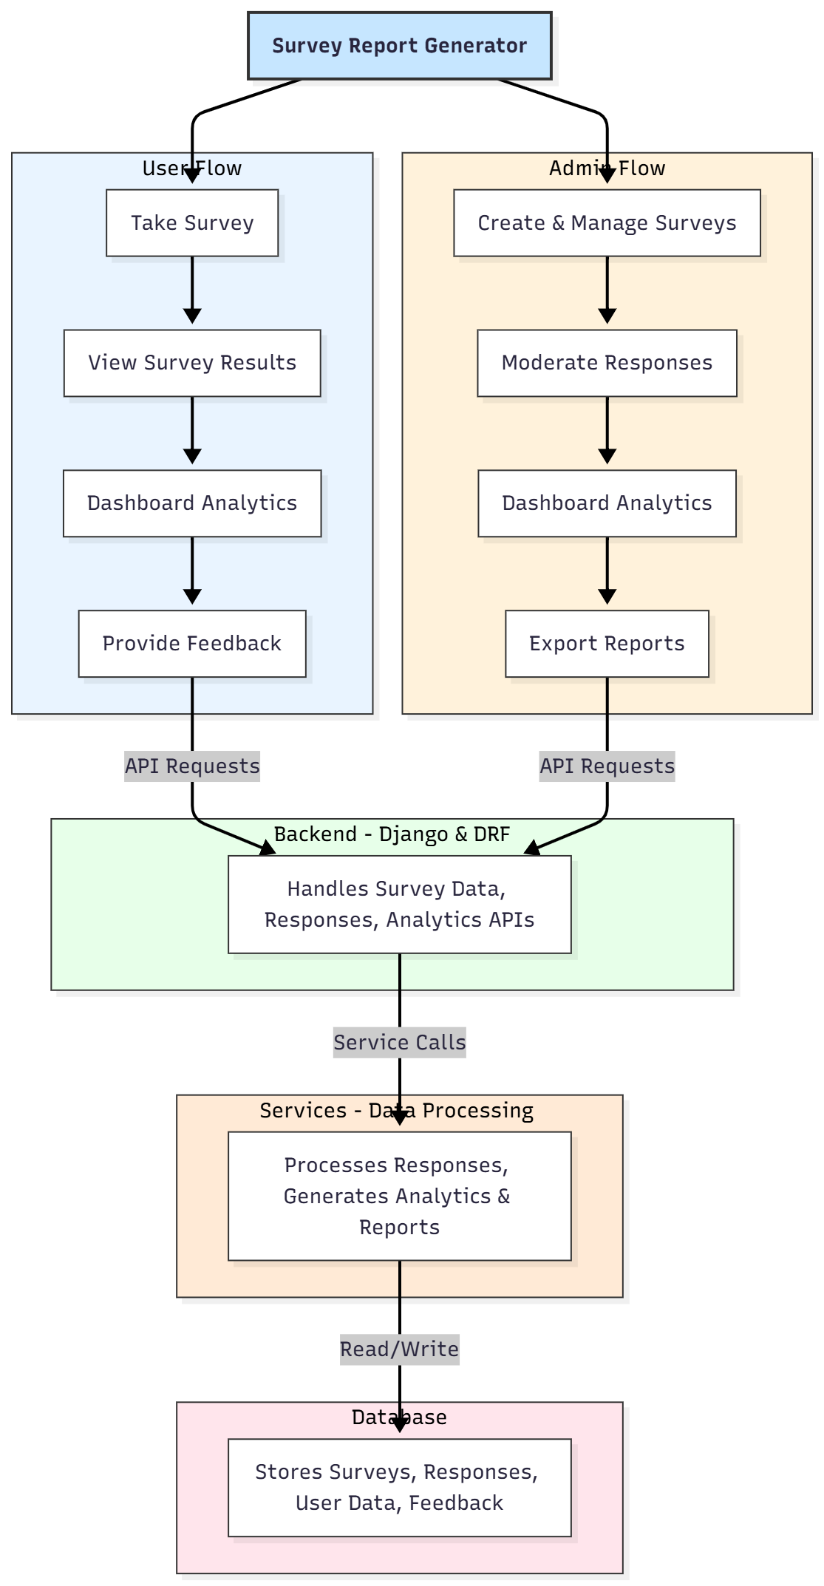

WORKING OF THE PROJECT:
The system allows administrators to create surveys with multiple question types and set availability parameters. Users access and take surveys through the web interface, and responses are securely sent to the backend. The backend validates data, updates participation status, and stores results in the database. Users can view their own results and visualizations on dashboards. Administrators can monitor responses, moderate data to maintain integrity, and generate comprehensive analytics and exportable reports. The services module processes responses and generates charts for real-time visualization. The database ensures secure storage of surveys, user responses, and feedback..

SOFTWARE REQUIREMENT:
- Backend:
  - Python 3.x
  - Django
  - Django REST Framework
  - SQLite/PostgreSQL
- Frontend:
  - Node.js and npm
  - React.js
  - Axios
- Development Tools:
  - Visual Studio Code
  - Postman (for testing APIs)
  - Git/GitHub (for version control)
- Server/Deployment (Optional):
  - Gunicorn, Nginx, or Heroku/AWS for hosting

ADVANTAGES OF THE PROJECT:

• Centralized survey creation and management
• Real-time response tracking and analytics
• Interactive dashboards for users and admins
• Secure storage of survey and participant data
• Exportable survey reports for decision-making
• Moderation of responses ensures data integrity
• Improves efficiency and accuracy of survey processes
• Scalable system suitable for HR, schools, clubs, and training programs

APPLICATIONS OF THE PROJECT:
• HR departments for employee surveys
• Schools and educational institutions
• Training and skill development programs
• Clubs and organizational feedback collection
• Market research and opinion polls
• Event and workshop feedback

REFERENCES:

- Django REST Framework Documentation — Django Software Foundation. Django Documentation. Available: https://docs.djangoproject.com/
- Django REST Framework. DRF Documentation. Available: https://www.django-rest-framework.org/
- React. React Official Documentation. Available: https://reactjs.org/docs/getting-started.html
- Redux. Redux Documentation. Available: https://redux.js.org/introduction/getting-started
- PostgreSQL Global Development Group. PostgreSQL Documentation. Available: https://www.postgresql.org/docs/
- MySQL. MySQL Reference Manual. Available: https://dev.mysql.com/doc/
- Git. Git Documentation. Available: https://git-scm.com/doc
- Node.js. Node.js Documentation. Available: https://nodejs.org/en/docs/
- Axios. Axios Documentation. Available: https://axios-http.com/docs/intro
- Socket.io Documentation – https://socket.io/docs/

